BHARANI

RAJADHURAI

Bsc computer science student

# PROFILE

Bsc computer science I consider my self a

responsible and orderly person.

I am looking foward for my first work

experience.

# CONTACT ME

9361742003

[bharani.r1003@gmail.com](mailto:bharani.r1003@gmail.com)

85,south Street Rettaravalasu Dharapuram

Tirupur.

# EDUCATION

## BHARATHIYAR UNIVERSITY

*cherraan's arts science college Bsc computer science*

2021-2024

# LANGUAGE

Native Tamil Basic English

# COMPUTER SKILLS

Edit

Spreadsheet.

Slide presentation.

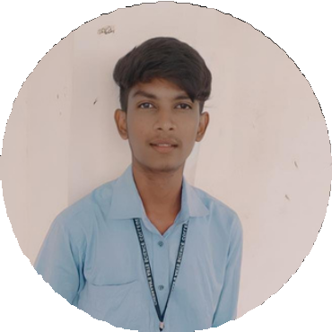

# VOLUNTEER EXPERIENCE

## VELVERAL FOODS INC.

Chennai silks Supervisor

2 year experience